**FACE TO EMOJI**

**Project Report**

Made By: Ajinkya Bedekar(U101116FCS183)

Dhruva Agarwal(U101116FCS177)

**Introduction**

Emotions play a vital role in every second of a person’s life. From the moment of their birth till their last breath, every emotion can be observed (for example, anger, disgust, fear, happiness, sadness, surprise and neutral) emotions.

A person always wants his surroundings to be according to his emotion. This is where our project meets Artificial Intelligence at a very basic level. It helps AI agent to adapt itself based on the emotions of the human it is interacting with.

We have used different tools and technologies explained later which were available with us to be able to classify that emotion.

Our software when run, is capable of detecting four of the many human emotions which are visible on their faces. The output of our software will include two types of data as an output:-

1. Name of the emotion detected.
2. Respective emoji of the emotion detected.

Emojis are basically graphical representation of emotion. Our software will be using these in order to make the working more interactive and fun.

**Motivation**

Facial expression recognition plays a crucial role in the area of human-machine interaction. Automatic facial expression recognition system has many applications in various streams including medicine, E-Learning, monitoring, entertainment, law and marketing.

Every stream in itself has numerous applications for this technology. Like, in the case of medicine, when AI has to deal with a patient of depression, it demands a very accurate use of emotion recognition system to come up with a required cure and process of improvement.

Also, if AI has to communicate with a physically handicapped person or a small baby who cannot speak properly or express itself with words, there is a huge demand of an ability of the system or software which can detect the emotions of the person it is interacting with.

If there is a way, we can customize the things according to our mood/emotions, it will give us a fully personalized experience.

Therefore, a human emotion recognition system is very much needed to ease our lives in a future environment that will be fully automated and controlled by Artificial Intelligence.

**Work Done**

The technologies used during the development of this project are as follows:

* Haar Cascade: haarcascade_frontalface_default.xml is used for face detection.
* Dataset: fer2013 dataset available from Kaggle is used for training the model to detect emotions.
* Emoji: Emoji module available in Python is used to print the emojis as terminal output.
* Keras: It is used for emotion classification.

The python code is able to detect the emotions on the person’s face in real time with the use of webcam. The bounded box is generated on the face and the emotion detected is printed as label on top left of the bounding box. The emoji mapped to the detected facial expression is printed on the terminal.

The workflow of our project is given below:-

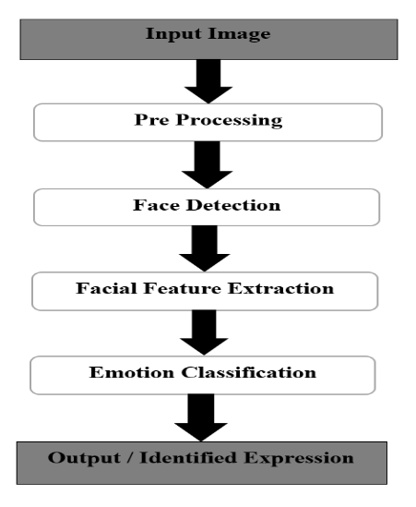

Results:

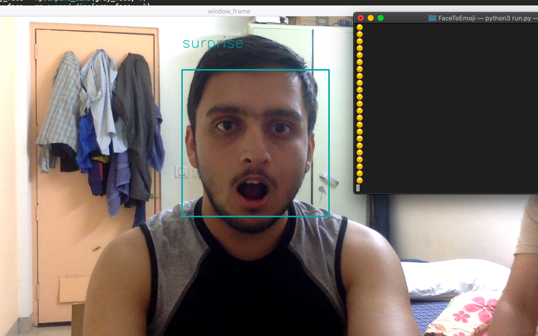

Emotion Recognized - Surprise

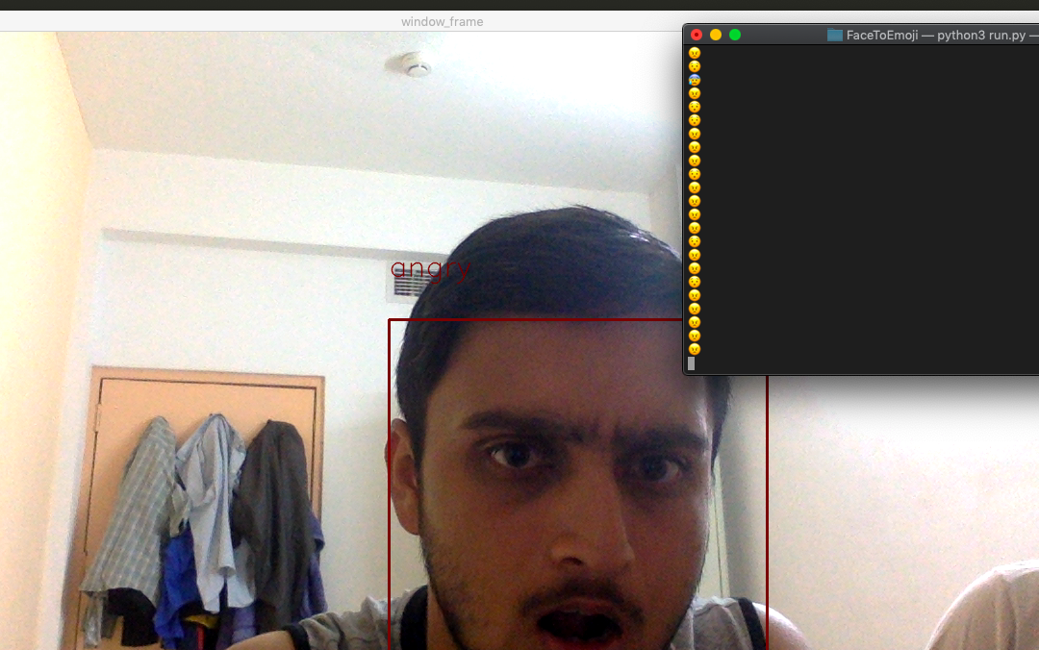

Emotion Recognized - Angry

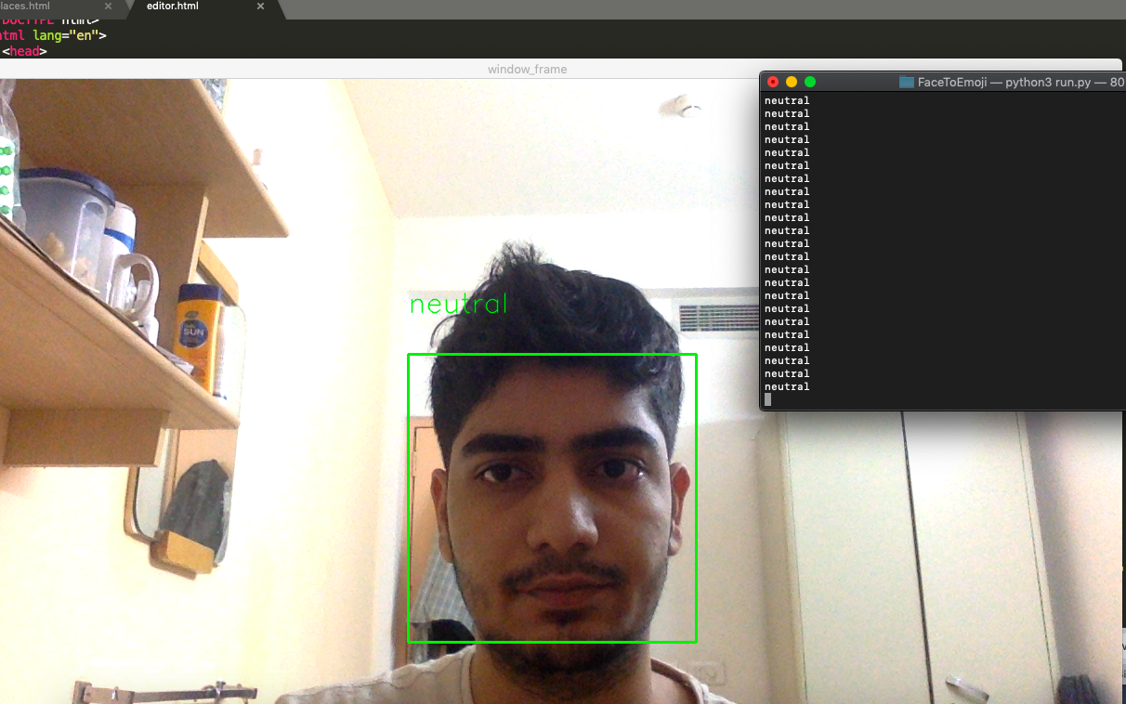

Emotion Recognized - Neutral

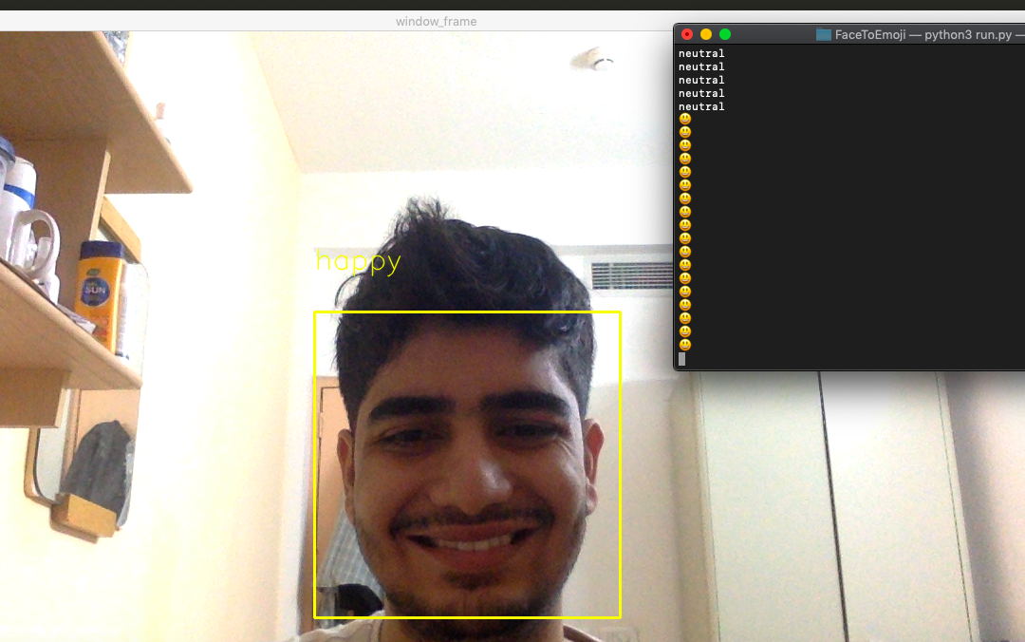

Emotion Recognized - Happy

**Application of Project**

## 

## In recent years, the use of facial expression recognition systems or softwares have been increasing. There are many applications of this product.

## **Market Research**: Based on the current customers and partners engagements, the company is able to deduce marketing strategies and customized products in order to retain them. An expression reader in this situation can be useful as it can record the customers’ or partners’ emotions by advertisements or meetings and thus aid the company with this data.

1. **Health and Medicine**: In the field of health, this product can help in many methods. In every aspect of health care, it can be used to determine the emotions of a patient undergoing a surgery or a treatment process and notify the respective doctor about them. Using them as a basis a doctor can advise a better treatment suitable for the patient and thus easing out the difficulties or pain for them.
2. **Psychology**: It is the scientific study of the human mind and its functions, and it is done for the purpose of education or research including the medicinal part. This product has a lot of uses in the field of psychology as psychology is very closely related to emotions. Thus, learning emotions of humans at different situations can give us a much better knowledge about his/her mental psychology.
3. **Autism**: It refers to a broad range of conditions which are characterized by challenges with social skills, repetitive behaviors, speech and nonverbal communication. Thus for a person who is incapable of reading expressions of the society and understanding their emotions, face expression recognition system can aid a lot by characterizing it for such people and thus make it easier for them to react in a social gathering and thereby easing their lives.
4. **Lie Detection**: The machine developed for lie detection uses the sensors to find any abnormality in the blood flow streams of the user. This product can aid it by characterizing any suspicious changes in the expressions/emotions of the person who is being tested.
5. **Security System**: In a environment like an ATM or a bank, where the treat to security is a major problem, the security cameras can be enabled with this software in order to detect any suspicious expression to enhance the precautionary measures.
6. **Education**: This product can be used to measure real-time learner responses and engagement with their educational content and thus adapt, personalize the content and measure effectiveness of lecturer.

**Drawbacks**

1. The project is able to detect only four facial expressions/emotions right now i.e. angry, sad, happy, and surprise.
2. It is not 100% accurate and needs improvement in it.

**Future Prospects**

The model needs to be trained more so that it becomes capable of detecting all human emotions. At the same time, the accuracy of the software is also aimed to improve.

**Conclusion**

So finally, our project is capable of successfully recognizing the expressions/emotions of human beings. It is working in a good condition and can be used for real time situations without any problems. It has some drawbacks which can be very easily overcome by training our model with more dataset. Also, it is giving us proper emojis for making the session more interactive.